A project report on

FlexDeal Shopping Website

Under the Guidance of **Dr. Uma Sheshadri Dr Shankar Biradar**

Course Name- Object Oriented Programming Course Code – CS207

Course Instructor - Dr. Uma Sheshadri.

Group Members

(Group11)

20BCS114 – Rohit Khetan 20BCS125 – Somisetty Sai Praneeth

20BCS126 – Soumya Ranjan Sahu 20BCS128 – Sreedeva Krupananda Reddy

20BCS129 – Sri Hari L

**INDIAN INSTITUTE OF INFORMATION TECHNOLOGY, DHARWAD**



# Table of Contents:

Contents

Table of Contents: 2

Acknowledgement: 3

Preamble: 3

1. Organization of Project 3

1.1 Abstract 3

1.2 Introduction 4

2. Investigations 5

3. Challenges in obtaining data. 7

3.1 Web Scraping 8

4. Results & Conclusion 9

4.1 Screenshots of the live functional website 9

4.3 Future Plans 12

4.4 References 12

# Acknowledgement:

This project report has been completed as partial fulfilment for the requirements of the degree B. Tech, under the guidance of Dr. Uma Sheshadri and Dr. Shankar Biradar, department of Computer Science and Engineering, as part of the Object Oriented Programming Course in Semester III.

# Preamble:

The goal of this project is to make online shopping as simple as possible by providing a user-friendly interface that allows us to save both time and money. So, keeping this in mind, we have come up with a comparison-shopping application called FlexDeal.

# Organization of Project

This project report shall be presented in four chapters, starting with Introduction, investigation, challenges, results, summary and conclusion.

## Abstract

In this era of online shopping, all of us want to buy our products at the cheapest possible price. We all want to know the different discounts across different e-commerce websites. Our website, FlexDeals, displays different products from e-commerce websites that have a discounted price. We also provide the price, ratings, discounted percentage, and a link to access the original website of the product. We aim to provide our users with a platform that can show them detailed information about all the discounts going on at various e-commerce websites. Our website also helps users directly buy the product by providing them with a redirecting link.

**You might be wondering, why would we need such a platform?**

*Shortlisting*, *filtering*, and *researching* takes away a lot of time, and when we have finally decided on what we want to buy, it can get cumbersome to find the best deals on that particular product. With Amazon, Flipkart, Myntra, Paytm and other similar platforms offering varied discounts, it can also get tough to fish out the best offers. That’s when we are going to need a platform like flexDeal.com – a one stop solution for online price comparisons across multiple product categories.

## 1.2 Introduction

Comparison shopping is a good option for those looking to save money and get the most value for the money. Though it sounds depressing, it can actually be challenging and rewarding. Analyzing brands to find out the best value for the price will be helpful to everyone. It’s not just to get the best products for their family, but it will also help save money in the long term. Even if they don’t exactly practice frugal living in all areas of their lives, they can still practice comparison shopping to get the most for money when certain purchases have been made.

Nowadays, shopping comparison entails more than just comparing prices. Finding the cheapest items is not the main purpose. Determining the best quality items for the least amount of money is the main challenge. That’s why comparison shopping is becoming an industry of its own.

Comparison shopping engines are similar to traditional search engines in that they allow us to search for a specific item of interest. Then there's a list of prices and retailers. It also displays customer reviews, which should be read before purchasing anything.

Making a price comparison website is not an automated process; rather, it is a manual task. I need to write automated scripts to try to automate all of that manual work. Even manually editing feeds is time-consuming, even if we only focus on a small range, because merchants do not provide us with the data that the price comparison site requires to function properly.

# ****Investigations****

**First Week:**

To come up with a project idea, we discuss the resources we have and which languages we are comfortable with. Some of the group members were familiar with HTML and Bootstrap classes for the front-end, some with the Django-Framework of Python for the back-end. So we decided to go for a full-stack responsive website development.

We decided to approach a unique idea to avail offers and discounts for a user-specified product.

And for this project, we decided to develop a comparison website, which will compare the prices of a user-specified product on different existing e-commerce websites and redirect the user to those websites where the product price falls under the user's budget.

**Second Week:**

For our idea, we started collecting references. Is there any existing website similar to us? If so, what are the features those websites have and how can we make our project unique from them?

We discussed every approach, feature, and user experience that could be implemented in our project within the time constraints.After all the prep work was done, we started modelling the application. We discussed the functions and method classes required for different features of our web-apps.

We started by collecting resources such as software and platforms to develop the application, then we distributed the work and assigned tasks among ourselves according to our skills and past experience. We had to learn the frameworks. And we started working on it.

**Week three:**

We created a user interface design for our application to provide users with a smooth and fast experience now that everything is organised in the planning board.And this week itself, we finished the front-end part and the user-login part in the backend.

This week might seem slow to you because our end-of-semester exam was coming up, and all the subject teachers were conducting quizzes and we had to prepare for the exam as well.

**Week four:**

This week we started working on web-scraping to gather data from different e-commerce websites. user-profile, reset password, and features like sign-up to create new accounts and a search bar where users can search for a product and the result will be displayed accordingly in the backend part.

We have now reached the final stage of our project, which is deployment to a server.

This weekend we are going to deploy our application to a server from which any user from anywhere will be able to use it.

# Challenges in obtaining data.

The most difficult aspect of a comparison website is obtaining data from merchants. One approach would be to contact them and collect data directly from them. Retailers will provide their own product and price lists. These are then compared to the original database. This can be accomplished through a combination of human labour and information extraction.

Another common method is to collect data via a data feed file. Merchants provide information in a predefined format via electronic means. The data is then imported by the Comparison website. Data feed consolidation can be found from some third-party businesses, so we don't have to import data from numerous merchants. Affiliate networks such as Linkshare and Commission Junction also aggregate data feeds from various merchants and offer comparison sites.

The third method is to search the internet for information and prices. Rather than waiting for retailers to supply data, the comparison service scans retail sites and collects information. This is also referred to as "scraping" information. It is appropriate for smaller independent sites to obtain direct prices from the website they require.

Another technique is crowd-sourching. Price comparison engines can acquire data from almost any source using this technique, avoiding the complexities of building crawlers. You don't even have to configure data feeds. In fact, visitors import data using this technique. Price comparison sites used collaborative filtering, artificial intelligence, or human labour to combine the data with related inputs before adding it to their main database.

## Web Scraping

Web scraping involves creating a special web bot (usually referred to as a crawler or spider) that checks search engines or specific websites constantly (or at least on a regular basis) and collects data from them. Crawlers can help you create and maintain a large database in a short period of time. This is yet another straightforward option for creating a vendor comparison website.

While it's polite to ask permission for most internet activities, web scraping can be done without permission from vendors. which understandably irritates the vendors As a result, website owners who do not want their sites to be associated with or featured on price comparison websites can create anti-crawler bots—bots that prevent automatic data collection.

Furthermore, web crawlers are not cheap to develop (or hire), are illegal to use without permission, and do not provide you with any direct profit. Crawlers are only useful if you need to give your website an advantage by having a larger database.

# Results & Conclusion

## Screenshots of the live functional website

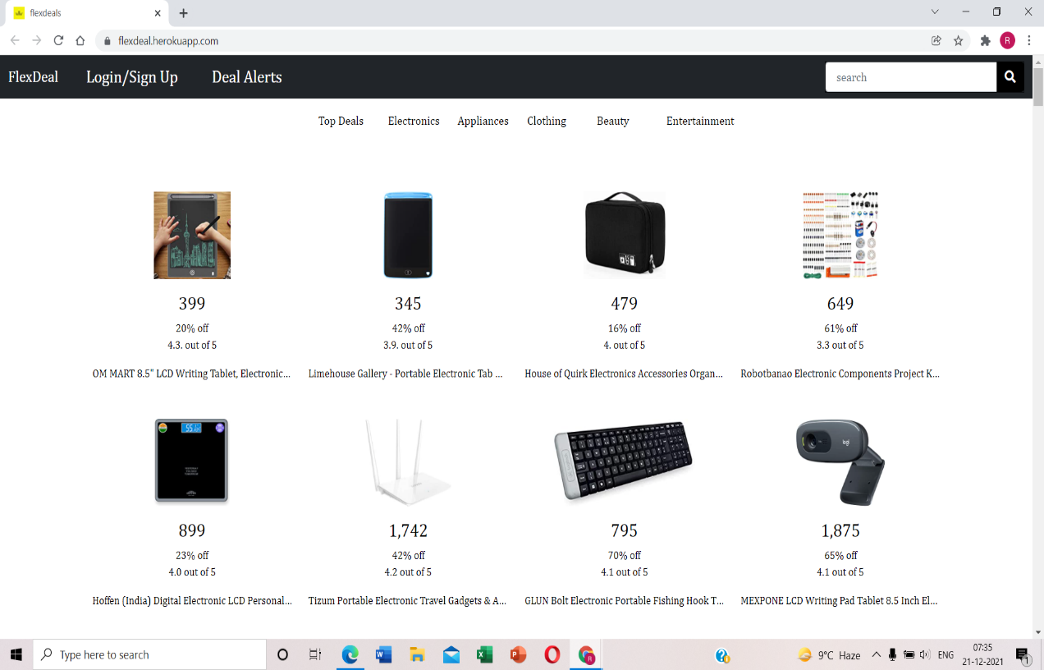

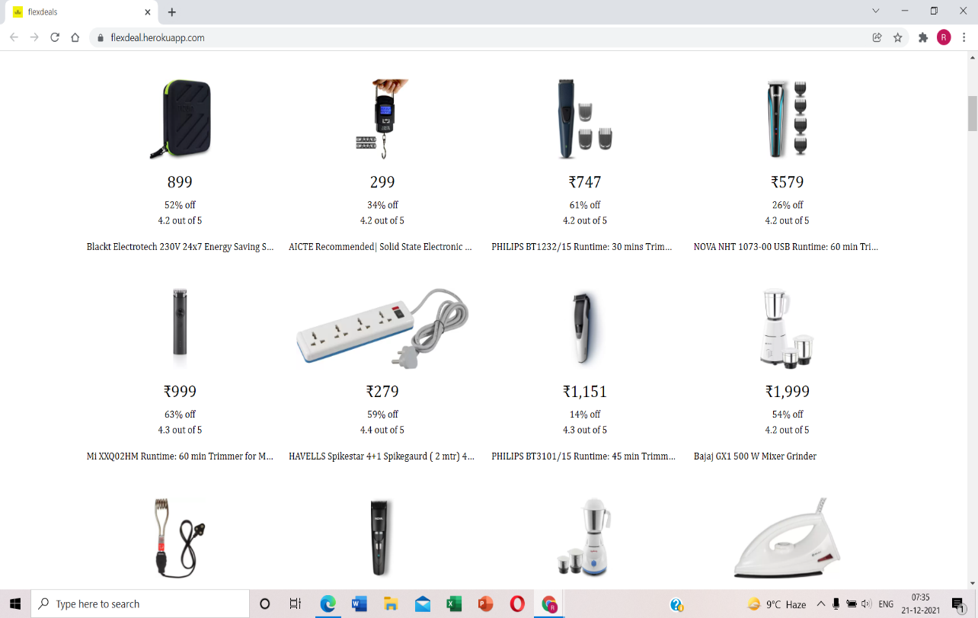

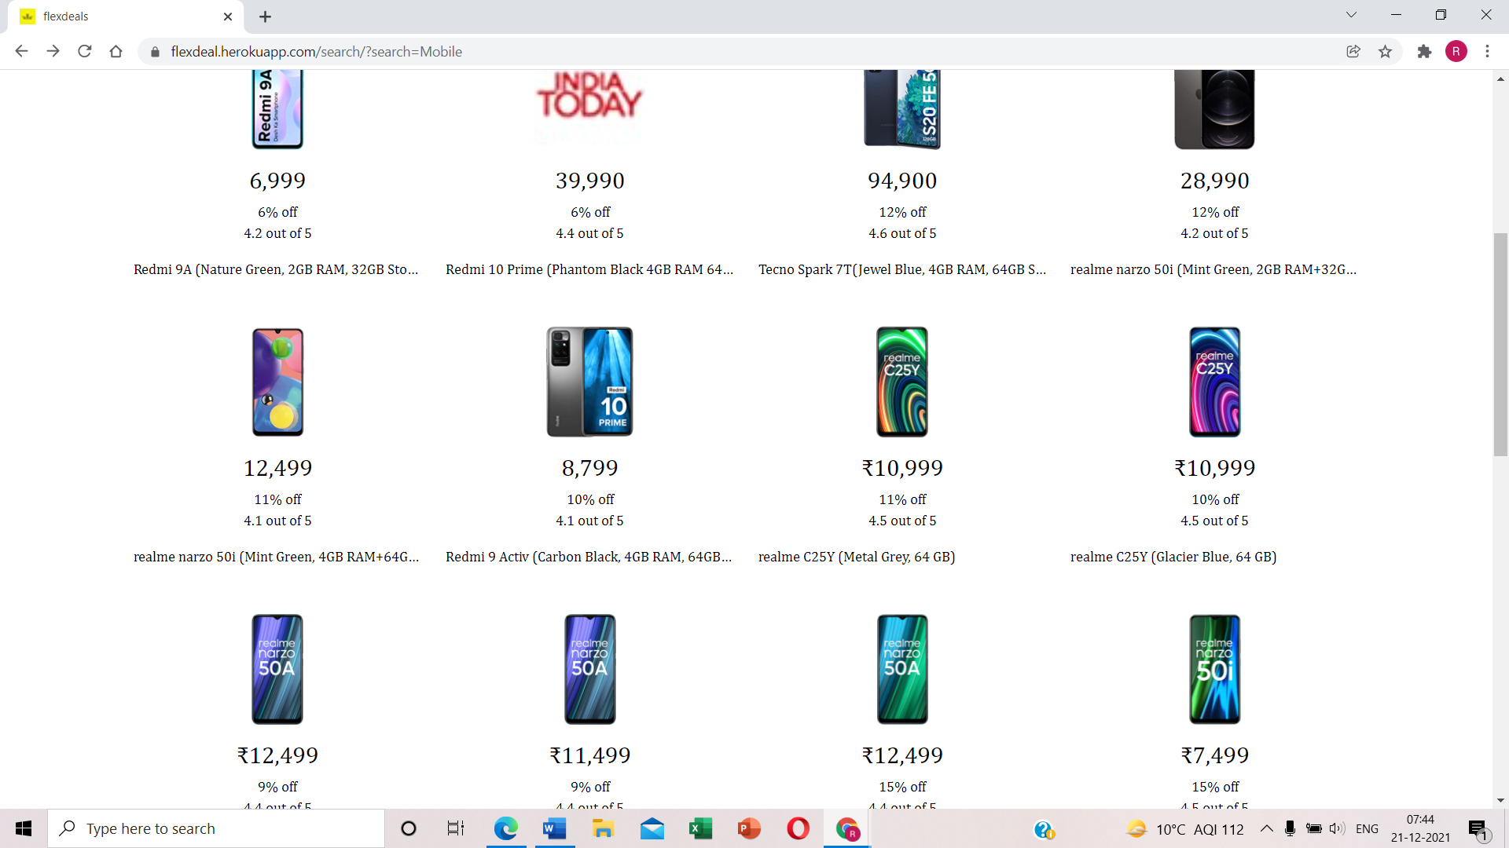

* 1. **Conclusion**

We try to spend as much time as we can, to check whether or not we are buying a right thing? And the most important; whether we are buying it at a reasonable rate or not? Providing the ability to compare products is at the heart of what comparison sites are trying to achieve. However, those sites are achieving this with varying levels of success. My target of website is simply log on to my website, learn about the products, search and browse the options and shop with satisfaction of trust and all these at your door steps.

Price comparison websites are understandably popular; after all, most people are concerned about their finances. Comparing prices is especially important when it comes to expensive items, but price comparison sites and apps are available even when it comes to grocery shopping. Furthermore, these services are about more than simply finding the best deals. Price comparison websites typically provide product information and, on occasion, news about deals and promotional campaigns. On the consumer side, this is true.

Businesses that sell goods and services, on the other hand. Price comparison websites are promotional platforms for them. Having an online store featured on a price comparison website increases the number of visitors and, as a result, buyers—that is, if the prices are competitive enough.

This is a web-oriented application that allows us to access the products that are available in discount sales on Amazon and Flipkart websites. This website provides plenty of products that are available for maximum discount sale. This generic application is designed for helping the user to find the best deals available for a product on those two shopping sites. Further, in the future, we are going to add the products of various other websites and some more interesting features too.

## Future Plans

Users who have created an account on this website could able to use some of the special features like

* + 1. Users can post their best deal(s), can like, dislike and comment on that post. This is to solve the fake reviews provided on the original websites.
    2. The favorite products of that user could be compared along with other websites (if available there) to know about the maximum benefits of his purchase.
    3. Users can create a wishlist of products they desired to track the price of, and this website will monitor the price changes over time for that user, and if there is a drop or change in a deal that user will be notified or gets an alert through email or message.
    4. Users can get view the price history of a particular product.
    5. Users can search the products over a fixed range of prices.
    6. Users can use the coupons for their purchases.

## References

* <https://www.cloudways.com/blog/price-comparison-websites/>
* <https://themindstudios.com/blog/how-to-make-a-price-comparison-website/>
* <https://camelcamelcamel.com/>
* <https://pricee.com/>
* https://www.shopping.com/